Heuristic Evaluation On Micro-Blogging Platforms

German University on Cairo

Supervisor: Dr. Wael

By:

Ahmed Hesham

Heuristic evaluation, is a technique developed originally in 1990 by Rolf Molich and Jakob Nielsen, before being improved in 1994 by Nielsen, to help locate usability problems, in user interface design. This technique however, is not a to be used as a replacement for usability testing, in which the interface is tested on actual users. Microblogging platforms are a new trend in the internet, where they are a hybrid of both blogging and instant messaging that enable users to post short messages in the form of a status, they are mostly used for promotions of products. The most renowned platform is Twitter.

Heuristic evaluation allocates 10 different assessors, to rate the interface according to predefined heuristics. Which are:

1. Visibility of system status - the system should provide appropriate feedback to users happening within a certain frame of time.
2. Match between system and real world - the system should be presented in the target user’s language and terminology and present information in logical order.
3. User control and freedom - the system should handle if a user should perform an unwanted function to roll back or reapply said operation, furthermore it should allow the user to opt out of an operation with a clearly marked exit button.
4. Consistency and standards - the system should not present ambiguous operations to the user; platform conventions should be applied.
5. Error prevention - error prone conditions should not exist or request user confirmation before they perform an error prone action.
6. Recognition than recall - users are not required to memorize the locations of items in the interface, they should be presented clearly, nor is the user required to remember information from one dialogue to another.
7. Flexibility and efficiency - system should cater to both experienced and inexperienced users by tailoring specific actions to each, for example accelerators are faster for experienced users.
8. Aesthetic and minimalist design - dialogues should only contain relevant information, any extra unneeded information reduces the visibility of required information.
9. Help users recognize, diagnose and recover from errors - error messages should be expressed in plain language (i.e. no advanced terminology), pinpoint the problem and suggest a valid solution.
10. Help and documentation - help and documentation should be available to the user, with tools for easy retrieval of information.

– Twitter

Launched in 2006 by Jack Dorsey. Over the years Twitter has had numerous make overs. This is current display of the timeline (Some data has been hidden for discretion):

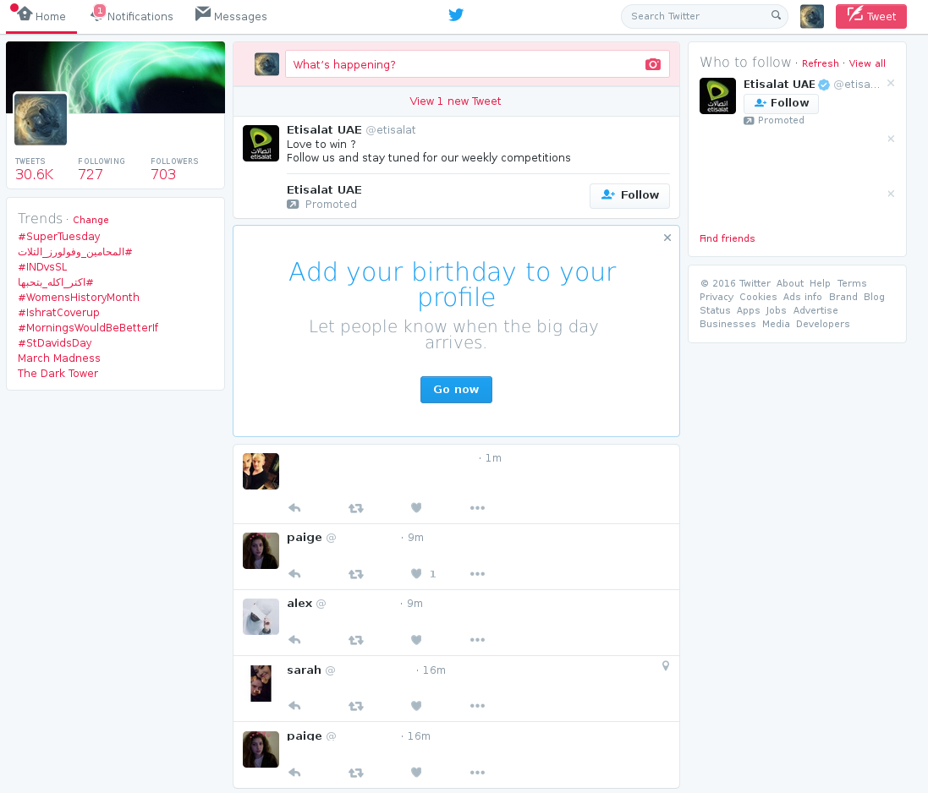

1. Visibility of system status – severity 0
   1. Compliances: the interface provides a constant update of the timeline for new tweets, which occurs every couple of minutes displayed as the box under the tweet option. The tabs in the top left are highlighted to indicate, which view the user is in.
2. Match between system and real world – severity 1
   1. Compliances: the interface does use simple terminologies for simple users; furthermore, simple icons are used to indicate operations, such as: retweet, like and more options. Tweets are shown in chronological order.
   2. Violations: the alias for the word “post” being “tweet”, may confuse new users as to what it performs.
3. User control and freedom – severity 3
   1. Compliances: when a user clicks a retweet button, they are faced the above dialogue, there is a close button, lest the user wishes to opt out.
   2. Violations: the close button is not big enough to catch the user’s attention, however it does exist. In addition, should a user wish to undo a retweet, they should navigate to their profile, find the retweeted tweet and reclick the retweet button to undo the action. Similarly, for like button. If a user accidently clicked the logout button in profile menu, there is no confirmation dialogue, they will be logged out directly.
4. Consistency and standards – severity 2
   1. Compliances: there are no ambiguous operations to the user.
   2. Violations: over the years, the favorite button has been changed from a star, to a heart with no notification to inform the user.
5. Error prevention – severity 2
   1. Compliances: prior to the switch to a JVM based language from ruby in 2011, twitter often faced overloads and went through numerous “down times”. After the switch the error no longer appears.
   2. Violations: random errors occur with no description indicating the cause, a message “an error has occurred” appears at the top of the page, offering the user to refresh the page in an effort, that the error will be fixed.
6. Recognition rather than recall – severity 1
   1. Compliances: all the main operations are layed out infront of the user for easy access
   2. Violations: the lists view is hidden inside the profile menu, new users won’t be able to find it easily. In addition the delete tweet option is hidden inside the more options button in the tweet
7. Flexibility and efficiency – severity 0
   1. Compliances: the interface caters for both advanced and novice users by providing buttons for all actions, and by providing shortcuts for advanced users. To access the list shorcturs list the user has to view it from profile menu
8. Aesthetic and minimalistic design – severity 0
   1. Compliances: twitter has been redesigning its interface over the years to match the current trends. As of 2014 it has switched over to minimalistic deisgn.
   2. Violations: dialgoues have been on point, except the find friends suggestion box, which offers corporate accounts being promoted due to advertisements, such as Etisalat.
9. Help users recognize, diagnose and recover from errors – severity 0
   1. Compliances: twitter provides clear markers for errors, for example when a user creates a tweet with more than 140 character, the tweet box turns red, extra characters are highlighted and tweet button it grayed out.
   2. Violations: random errors occur, with no indication as to what causes them except that they ask user to refresh the page.
10. Help and documentation – severity 1
    1. Compliances: twitter has a vast support center, including how to use twitter for new users
    2. Violations: the help center is located in the profile menu, which can be hard to find for new users.

– Tumblr

Another microblogging platform founded by David Karp in 2007. Similar to twitter, it offers the users to upload pictures and videos and to create posts but without the limitation on text size.

The landing page after logging in